**Stopwatch Exercise - Visual Basic**

This Exercise will show you how to make a stopwatch in visual basic:

Add a label to the form and change its text to 00:00:00:000

To do that right click on the label and click on properties. In the properties window, change the text as follows:

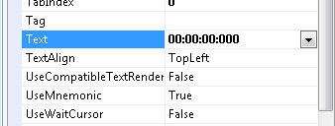

Change the font's size of the label. In the properties window, go to Font:

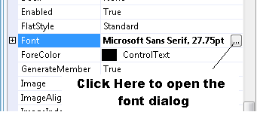

The font dialog will show up. Under the size, choose the number 28 then click Ok:

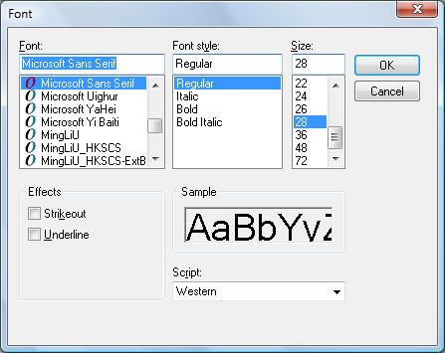

Add a timer to the form:

In the toolbox, drag the timer to the form. The timer will appear in the gray area below the form:

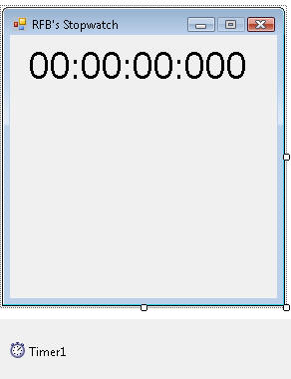

Right click on Timer1 and click on properties. In the properties window, change the interval property to 1.

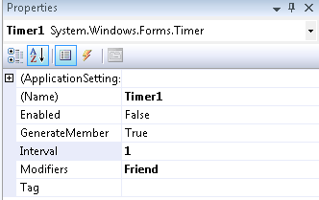

Drag a listbox from the toolbox and place on the form as the picture below:

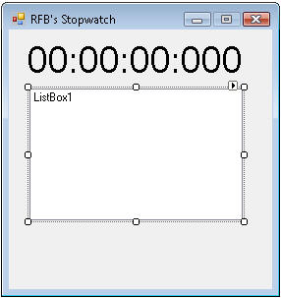

Add a button to the form and change its text to Mark:

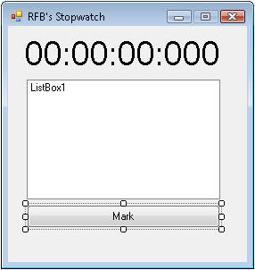

Add a button and change its text to Start:

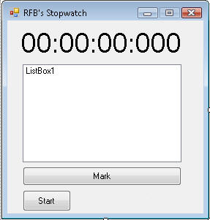

Add a button and change its text to Stop:

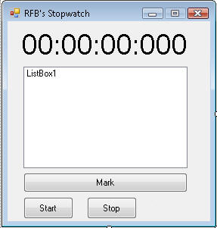

Add a button and change its text to Reset:

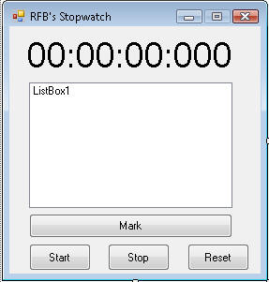

Let's write the code for the stopwatch:

Right click on the form and click on View Code. Add the following declaration below **Public Class Form1**

|  |  |
| --- | --- |
| 1 | Private stopwatch As New Stopwatch |

Add the following Timer Tick event code:

|  |  |
| --- | --- |
| 1  2  3  4  5  6  7 | Private Sub Timer1_Tick(ByVal sender As System.Object, ByVal e As System.EventArgs) Handles Timer1.Tick      Dim elapsed As TimeSpan = Me.stopwatch.Elapsed      Label1.Text = String.Format("{0:00}:{1:00}:{2:00}:{3:00}", _      Math.Floor(elapsed.TotalHours), _      elapsed.Minutes, elapsed.Seconds, _      elapsed.Milliseconds)  End Sub |

Add the following Start Button click event code

|  |  |
| --- | --- |
| 1  2  3  4  5 | Private Sub Button2_Click(ByVal sender As System.Object, ByVal e As System.EventArgs) Handles Button2.Click          Timer1.Start()          Me.stopwatch.Start()          Button4.Enabled = False      End Sub |

Add the following Stop Button click event code

|  |  |
| --- | --- |
| 1  2  3  4  5 | Private Sub Button3_Click(ByVal sender As System.Object, ByVal e As System.EventArgs) Handles Button3.Click          Timer1.Stop()          Me.stopwatch.Stop()          Button4.Enabled = True      End Sub |

Add the following Reset Button click event code

|  |  |
| --- | --- |
| 1  2  3  4  5 | Private Sub Button4_Click(ByVal sender As System.Object, ByVal e As System.EventArgs) Handles Button4.Click          Me.stopwatch.Reset()          Label1.Text = "00:00:00:00"          ListBox1.Items.Clear()      End Sub |

Add the following Mark Button click event code

|  |  |
| --- | --- |
| 1  2  3 | Private Sub Button1_Click_1(ByVal sender As System.Object, ByVal e As System.EventArgs) Handles Button1.Click          ListBox1.Items.Add(ListBox1.Items.Count + 1 & " " & Label1.Text)      End Sub |

Test your program and Enjoy

